**Pet Diet and HealthCare Planner**

**By**

Mahpara Saleem

01-235142-028

IT-F17-14

**Supervised by**

Mrs. Saima Jawad



Department of Computer Science

**Bahria University Islamabad**

A Report is submitted to the Department of Computer Science,

Bahria University Islamabad

In partial fulfillment of requirement for the degree of BS (IT)

# Certificate

I, Mahpara Saleem stated that the project ’Pet Diet and Healthcare Planner’ and the work offered in it, is my own. Where I have checked the available effort of others, this is openly mentioned in this document. I have clearly accredited the core resources of support.

__________________ __________________

Head of Department Supervisor

__________________ __________________

Internal Examiner External Examiner

# Dedication

Allah Almighty, who provided me the capability, to finish my final year project. It was a fresh practice, rousing but inspiring and definitely a great supervision towards market projects. I feel blessed to perform with such a devoted supervisor Mrs. Saima Jawad and supportive teachers of Bahria University Islamabad Campus.

# Acknowledgements

I am very pleased with all my teachers and especially my project supervisor Mrs. Saima Jawad for giving me a chance to work on pet diet and healthcare planner as my final year project and renovating my theoretical knowledge in practical considerate. By the grace of almighty God, I have effectively finished my final year project as per requirement of BSIT-Degree Program.

# Abstract

Pet Diet and Healthcare Planner is an industrial level project it is a requirement of Islamabad pets & AVIAN Hospital G-8 branch. Currently project is focusing on cats, dogs, chickens/hens, parrots and fishes. It is a complete platform for diet plans, notify the owner on the proper timings that when your pet need food and also provide the healthcare services (like pet disease and treatment Detail). Users can visit the doctor’s profile and can fix the appointment.

Table of Contents

Certificate 3

Dedication 4

Acknowledgements 5

Abstract 6

Introduction 13

1.1 Background 14

1.1.1Methodology 15

1.2 Problem Description 15

1.3 Objectives 15

1.4 Project Scope 15

1.5 Tools/Technology 16

1.5.1 Android Studio 16

1.5.2 Firebase 17

1.5.3 SQLite 17

1.5.4 PhpMyAdmin Tool 17

Literature Review 18

2.1 Dog Walk [9] 19

2.2 My Pet Reminders [10] 20

2.3 Dog Sync [11] 20

2.4 ASPCA Pet Safety [12] 21

2.5 Dog Health [13] 22

2.6 Pet Coach [14] 22

2.7 Pet-First Aid [15] 23

2.8 Rover [16] 24

Requirement Specifications 25

3.1 Existing System 26

3.2 Proposed Systems 26

3.3 Requirement Specifications 26

3.3.1 Functional Requirements 26

3.3.1.1 Functional Requirement 1 (Registration) 26

3.3.1.2 Functional Requirement 2 (Login) 27

3.3.1.3 Functional Requirement 3 (Add/View/Delete/Update pet Details) 27

3.3.1.4 Functional Requirement 5 (Download Application) 27

3.3.1.5 Functional Requirement 6(Logout) 27

3.3.2 Subsystem Functional Requirement 27

3.3.2.1 Login Processing 27

3.3.3.2 Validation Check 28

3.3.3 Non Functional Requirement 28

3.3.3.1 Performance 28

3.3.3.2 Accuracy 28

3.3.3.3 Maintainability 28

3.3.3.4 Portability 28

3.3.3.5 Availability 28

3.3.3.6 Flexibility 29

3.3.3.7 Usability 29

3.4 Use Cases 29

3.4.1 Use Case for the Web portal 30

3.4.2 Use Case for the Android Application 31

System Design 47

4.1 System Architecture Diagram 48

4.2 Design Methodology 49

4.3 High Level Deign 49

4.3.1 Flow Chart 49

4.3.1.1 Flow Chart (Pet Hospital Administrator) 50

4.3.1.2 Flow Chart (website user) 51

4.3.1.3 Flow Chart (Android Application user) 52

4.3.2 Activity Diagrams 53

4.3.2.1 Activity Diagram (Pet Hospital Administrator) 53

4.3.2.2 Activity Diagram (website user) 54

4.3.2.3 Activity Diagram (Android Application user) 55

References 56

**List of Tables**

Table 3.1: Registration Specification 32

Table 3.2: Login Specification 33

Table 3.3: Add Deals Specification 34

Table 3.4: View Deals Specification 35

Table 3.5: Update Deals Specification 36

Table 3.6: Delete Details Specification 37

Table 3.7: Logout Specification 38

Table 3.8: Registration Specification 39

Table 3.9: Login Specification 40

Table 3.10: Add Details Specification 41

Table 3.11: View Details Specification 42

Table 3.12: Update Details Specification 43

Table 3.13: View Notification Details Specification 44

Table 3.14: Delete Details Specification 45

Table 3.15: Logout Details Specification 46

**List of Figures**

Figure 2.1 Dog Walk 19

Figure 2.2 my pet Reminders 20

Figure 2.3 Dog Sync 21

Figure 2.4 ASPCA 21

Figure 2.5 Dog Health 22

Figure 2.6 Pet Coach Error! Bookmark not defined.

Figure 2.7 Pet First Aid 23

Figure 2.8 Rover 24

Figure 3.1 Use Case Diagram of a Web Portal 30

Figure 3.2 Use Case Diagram an Android User 31

Figure 3.3 Registration Specification 32

Figure 3.4 Login Specification 33

Figure 3.5 Add Details Specification 34

Figure 3.6 View Details Specification 35

Figure 3.7 Update Details Specification 36

Figure 3.8 Delete Details Specification 37

Figure 3.9 Logout Specification 38

Figure 3.10 Registration Specification 39

Figure 3.11 Login Specification 40

Figure 3.12 Add Details Specification 41

Figure 3.13 View Details Specification 42

Figure 3.14 Update Details Specification 43

Figure 3.15 View Notification Details Specification 44

Figure 3.16 Delete Details Specification 45

Figure 3.17 Logout Specification 46

Figure 4.1 System Architecture Diagram 48

Figure 4.2 Design Model 49

Figure 4.3 Flow Chart of a system (Pet Hospital Administrator) 50

Figure 4.4 Flow Chart of a system (Website user) 51

Figure 4.5 Flow Chart of a system (Android Application User) 52

Figure 4.6 Activity Diagram (Pet Hospital Administrator) 53

Figure 4.7 Activity Diagram for a web user 54

Figure 4.8 Activity Diagram for an Android app user 55

**Chapter # 1**

# Introduction

## 

## 1.1 Background

Pets are not humanoid however they show a lot of human aptitudes like sturdy personality, excitements, spirits, modes etc. Pets work virtuosos for our soul, body, and mind. They excite our wisdom of wellbeing. They offer us friendship, provide us enjoyment, and overhead everything they provide us happiness. Pet usually do not care about; how we are looking? , what is our financial status? , and what is our state of mind, race, age and health is? They understand and appreciate us for what we are; subtracting the frills of our daily life. It is perhaps this feature of non-categorical response that pets separate us from individuals.

Anyone who kept a pet will know well that pets are the cause of relaxations in times of sadness. Pets are like our family members, caring for a pet is like caring for a child. In case for grief and sorrow leads to form as grow up and mature like death of a friend or a life partner, the loss of money or a loss in business, injury of a physical capabilities, privation of the chances to fix significant effort, and specially the loss of significance. Considering later a pet usually includes actions, for example walking with the pet, training the pet, monitoring the pet, playing with the pets. These all actions are significant since they support the pet owner to keep energetic. So it is very necessary to develop such applications which are essential for the health and survival of pets.

Pet Diet and Healthcare planner is an industrial level project and requirement of the Islamabad Pets & AVIAN Hospital G-10/4 Islamabad. It is a mobile and web based platform to generate daily and weekly diet plans (according to their age and specie).It will also provide feature for pet identification and notification about the feed timings and healthcare services (like pet disease detail and treatment plan). Users can visit the doctor’s profile and can fix the appointment through the website.

### 1.1.1Methodology

First of all user will register and then log in into the system. After the successful log in, user will visit the home page/home activity. Home page will contain many activities like; on clicking the Pet Registration user can add his/her pet details into the Database. Pet Profile activity will fetch and display all the pet information from the database. On the basis of pet age and specie the proper diet plan will be schedule from the database. Notification will send on the proper timings. Similarly pet treatment suggestions and pet common diseases will be fire from the data base on the basis of species. User can view the doctor’s profile which is saved in the database and can take the appointment from the doctor.

## 1.2 Problem Description

Understanding a pet is usually the most difficult task for pet owners. People do not know how to take care of their pets if they are sick and they rely only on their own past experiences with a specific animal. Usually people forget to feed their pets on time because of working in office or many other reasons. So it would be better to notify users regularly and timely using a mobile app. Most of us are hesitant in pet’s trade due to lack of guidance, and we suffer many loss of their life. Pet’s needs to be carefully fed, with a proper diet plan, or visiting a veteran if they are sick. There are many android and web applications that concern pets but most of them limited to only few features.

## 1.3 Objectives

“To develop a mobile application supported with a web portal for the pet diet planning and healthcare services.”

## 1.4 Project Scope

1. Currently the application will focus on the following cats, dogs, chickens/hens, parrots and fishes.
2. Pet diet plans (daily and weekly) are the part of this project.
3. Common diseases of the pet.
4. Treatment details will be shown to app user.
5. Separate slider tab to make an appointment or contact to the pet doctor in case of emergency.
6. Currently pet tracking is not the part of this project.
7. The application may support (Firebase, SQLite or My-PHP-Admin database’s) as per requirement.

## 1.5 Tools/Technology

Hardware:

1. Laptop
2. Tablet
3. Android Phone
4. Android Cable

Software:

1. Android Studio 2.3.3
2. Dream Viewer
3. Wamp / Zamp Server
4. Database; Firebase , SQLite or phpMyAdmin which is the most feasible

### 1.5.1 Android Studio

Android is an operating system for the smart phones. The past of android is Comprise of numerous versions like jelly bean, kit Kat etc. Currently it is converted as greatest dominant station. While websites occupies large audience become needs to integrate the mobile application with website.

### 1.5.2 Firebase

Firebase is a platform for mobile and web application development. It was created by Firebase Inc., but later acquired by tech giant Google, since then it has been used to create Mobile application and web based applications. Firebase also gives free of cost Real Time cloud services to the developers.

### 1.5.3 SQLite

SQLite is a relational Database management system made using C language. SQLite is embedded in the program. It’s not a typical client -server database engine.

### 1.5.4 PhpMyAdmin Tool

PhpMyAdmin is a free administration tool which is used for two types of DBs, MySQL, and MariaDB. It is a portable web application which is written in PHP. It is one of the Main free administration tool used with famous local hosts like Wamp server and Xamp server.

**Chapter # 2**

# Literature Review

Pet Diet and Healthcare Planner is important for our daily life which is used by the pet owner. Pets are the member of our family and it is very important to take care of them. The application will help pet owner to take care of their beloved pets and keep in touch with by proper diet plans, treatment suggestions and make appointment or contact with pet doctor in case of emergency. Some other applications that are in market are as follows:

## 2.1 Dog Walk [9]

It is application for both android as well as IOS users. The application is very helpful. The application users can perform multiple tasks through this application; for example user can track and record pet daily routine base activities like walk of dog. The walk is recorded when pet owner or user turn on the GPS in his mobile. Through this application pet owner can see the moves of his dog but the application is confined to the walk of your dog. Pet diet plans, diseases details and treatment suggestions are missing.

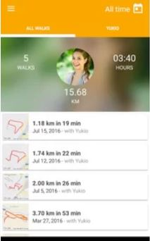

Figure 2.1 Dog Walk

## 2.2 My Pet Reminders [10]

My pet Reminder is mobile base application for android and IOS mobile user. This is useful in making a pet profile, generating a reminder of pet important dates for example birthday or appointment but the pet diet, diseases, treatment suggestions and healthcare services functionalities are not the part of this application currently.

## C:\Users\cell spot\Desktop\PET-PICS\pet-reaminder.JPG

Figure 2.2 my pet Reminders

## 2.3 Dog Sync [11]

It is web portal. This is very useful application in recording pet activities for example when the pet watered, when the pet walked, when the medicine is given and when the pet is fed. User can also share this record with the friends and other users of this application. This web application lacks the pet diet plans and diseases details and some other necessary healthcare services. This application is limited to only dogs. Android version and IOS version of this application is currently not available.

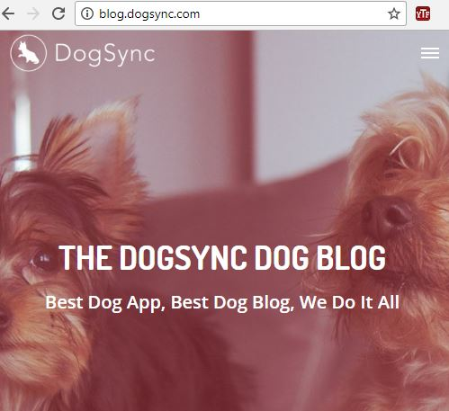

Figure 2.3 Dog Sync

## 2.4 ASPCA Pet Safety [12]

The ASPCA has number of applications for the pet owners. This application is limited to pet safety in case of pet is lost. The application also helps in finding the pet. The ASPCA Pet Safety app is accessible for both Android and IOS users. The application plays an important role in helping the users to make plan for pet protection during disasters, natural ruins and in extreme climate. The application imparts protection and awareness hints, and offers different techniques that how user can search for his/her lost pets in the case of emergency and what kind of tools are useful in storing. ASPCA is confined or limited to the pets protection it lacks pets daily and weekly diet plans and diseases and some other healthcare services.

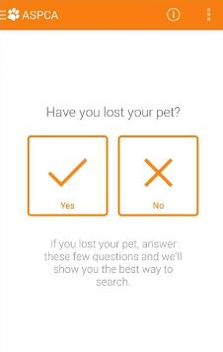

Figure 2.4 ASPCA

## 2.5 Dog Health [13]

This is a mobile base application and it is very useful application and is used to generate reminders about the appointments. This application also keeps the record of the previous visits to the pet doctor and stores all the medication that has to be done. Currently the application is limited to dogs and other kinds of pet like cats; hens etc are not the part of this application.

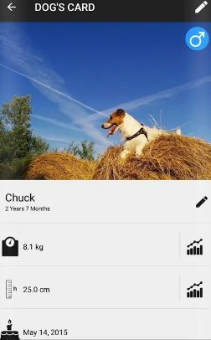

Figure 2.5 Dog Health

## 2.6 Pet Coach [14]

Pet coach is a complete platform for the web, android and IOS users. The application generates the advices and tips for pet’s health from the professional pet doctors. After installing this application anyone can post the question related to his pet diet, behavior and training. Consultations are free and well as paid for the users. Although pet coach is a very useful application but this is limited to take an appointment or advises from the doctor. While weekly and daily diet plan, pet common diseases, treatment plan and notifications features are considered as out of scope now.

## C:\Users\cell spot\Desktop\PET-PICS\pet-coach.JPG

## 

## Figure 2.6 Pet Coach

## 2.7 Pet-First Aid [15]

Pet-First Aid based upon a very unique idea by American android and IOS developer Red Cross. Application includes the photos, videos, tips and first aid guidelines in case of emergency or injury. If the injury of the pet is very swearer then the application can view the hospital list located nearby or contact the pet doctor. While using this application user can’t view the diet plan, common diseases, treatment plan and notification features.

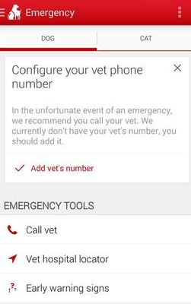

Figure 2.7 Pet First Aid

## 2.8 Rover [16]

Rover is complete platform web, android and IOS users. It basically establishes the network of such persons who are dog owner. Dog owners usually find too much difficulty in finding the sitters and boarding. This application is limited to provide facility to the dog owners in booking sitters for their dogs for boarding purpose, finding dogs care center, and send notifications to the pet users related to the updated photos of home sittings. Although this is very useful but confined to the dogs day care centers and homes.

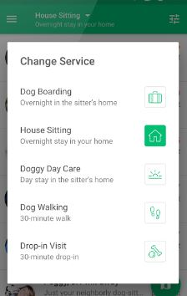

Figure 2.8 Rover

**Chapter # 3**

# Requirement Specifications

## 3.1 Existing System

There are many android applications which are related to pets but few are discussed in details the previous chapter 2. Most of them work on the specific single feature; for example Rover is an application which helps in searching the dog day care centers. Pet First Aid helps in searching out the pet hospitals in case of emergency. Pet Coach helps in taking out the advices and tips from the professional pet doctor. Dog Health is confined to the dog health only. ASPCA Pet Safety helps the pet owners in the case of pet loss. Dog walk is limited to record the walk and activities of dog. My Pet Remainder helps to notify the owner related to important dates of his pet like birthday etc.

## 3.2 Proposed Systems

Layman who buys the pet doesn’t know the proper diet plans or forget to fed, their common diseases and treatment suggestions. Pet Diet and Healthcare planner is an industrial level project and it is the requirement of the Islamabad Pets & AVIAN Hospital G-10/4 Islamabad. It is a complete platform for diet plans, notify the owner on the proper timings that when your pet need food and also provide the healthcare services (like pet disease and treatment Detail). Users can visit the doctor’s profile and can fix the appointment.

## 3.3 Requirement Specifications

## 3.3.1 **Functional Requirements**

### 3.3.1.1 Functional Requirement 1 (Registration)

Description:

Registration is compulsory for everyone (Pet Hospital Administrator or application user) who is using the application for the first time. Registration will perform to ensure the user account.

### 3.3.1.2 Functional Requirement 2 (Login)

Description:

After the successful registration Pet Hospital Administrator or pet owner is able to log in into the system through the registered email and password.

### 3.3.1.3 Functional Requirement 3 (Add/View/Delete/Update pet Details)

Description:

Administrator can add, delete, update or view the pet diet plans, diseases details and treatment details etc. While the application user can only add, delete, update and view the pet profile, diseases details and notification details and can add the appointment.

### 3.3.1.4 Functional Requirement 5 (Download Application)

Description:

Pet owner can download the android application in order to view the pet details.

### 3.3.1.5 Functional Requirement 6(Logout)

Description:

Pet Hospital Administrator or Application users can logout at any time.

## 3.3.2 Subsystem Functional Requirement

### 3.3.2.1 Login Processing

Description

Login activity is being performed on the system.

### 3.3.3.2 Validation Check

Description

While log in into the system; system will perform validation either the email or password is correct or not.

## 3.3.3 Non Functional Requirement

### 3.3.3.1 Performance

Least specification constraint is performed by the personal computer and which is necessary every platform like android or web application. Memory, processor and operation system should match with the application.

### 3.3.3.2 Accuracy

If the application display the correct results if user want to search the pet diseases or treatment details etc according to user choice at run time then the application will be accurate.

### 3.3.3.3 Maintainability

The developer will perform the maintenance of both applications; android as well as web application if some issue occur.

### 3.3.3.4 Portability

It is true that now a days users demand the portable applications. Pet Diet and Healthcare is portable because it is available on both platforms android and as well as web.

### 3.3.3.5 Availability

Application user is capable to perform and view application details on any time.

### 3.3.3.6 Flexibility

Pet diet and Healthcare planner has fully compatible and flexible system and easy to use for the end users.

### 3.3.3.7 Usability

The interface and Graphical User Interface design of the application is user friendly with no training required

## 3.4 Use Cases

Uses case diagrams are very important because they help in understanding the whole system in a shorter time or quickly. Use case diagrams are designed for the both platforms android as well as for the web site.

### 

### 3.4.1 Use Case for the Web portal

Admin has the authority to add, view, update or delete pet or user details. After logging into the web application the customer can view all the details mentioned in the web portal. Customer can also view the contact the details from the web site and can contact the pet doctor.

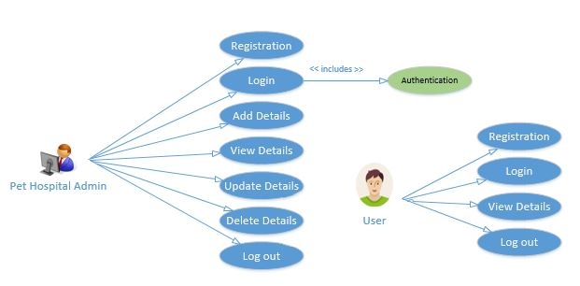

Figure 3.1 Use Case Diagram of a Web Portal

## 

## 3.4.2 Use Case for the Android Application

Application user or pet owner can add, view, update or delete his pet profile. After logging into the system the customer can view all the details mentioned in the android app. User can also make an appointment and view the contact the details and can contact the pet doctor android user can view the diet plans, notifications details, diseases and treatment details and can also appoint a doctor after logging in to the system.

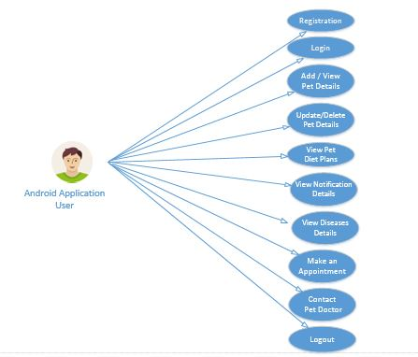

Figure 3.2 Use Case Diagram an Android User

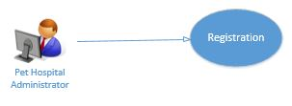

Figure 3.3 Registration Specification

*Pet Hospital Administrator* will register himself by filling registration form in order to add more information related to pets. Provided information will be verified and after the successful registration the *Pet Hospital Administrator* will be registered.

|  |  |
| --- | --- |
| **Name** | Registration |
| **Actor** | *Pet Hospital Administrator* |
| **Brief Description** | A *Pet Hospital Administrator* is able to register as a new Administrator. |
| **Flow of Events** | *Pet Hospital Administrator* will fill the registration form and then click on submit button.  Information will be validated and a verified.  After the Successful registration *Pet Hospital Administrator* will be registered  *Pet Hospital Administrator* can access the Website by logging in to the system. |
| **Alternate Flow of**  **Events** | If validation fails, then user can resend it.  If mandatory fields are not filled, user will be prompted to fill them all. |
| **Pre-condition** | All fields of registration age are essential. |
| **Post condition** | User will become registered. |

##### Table 3.1: Registration Specification

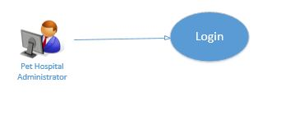

Figure 3.4 Login Specification

*Pet Hospital Administrator* is able to login into the system but after the successful registration. Provided information will be verified and after the successful validation the *Pet Hospital Administrator* will be able to Login.

|  |  |
| --- | --- |
| **Name** | Login |
| **Actor** | *Pet Hospital Administrator* |
| **Brief Description** | *Pet Hospital Administrator* will login to do multiple operations. |
| **Flow of Events** | After the successful registration and login the *Pet Hospital Administrator* will able to access the system.  The administrator is able to Add or View the details. |
| **Alternate Flow of**  **Events** | If the fields are missing the *Pet Hospital Administrator* can refill the required fields. |
| **Pre-condition** | All fields of login page are essential. |
| **Post condition** | After the successful login the *Pet Hospital Administrator* will be able to add or update details. |

##### Table 3.2: Login Specification

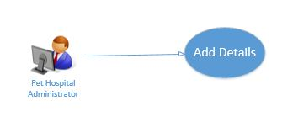

Figure 3.5 Add Details Specification

*Pet Hospital Administrator* has the authority to add details upon successful login. *Pet Hospital Administrator* can to add more information or to promote his website.

|  |  |
| --- | --- |
| **Name** | Add Details |
| **Actor** | *Pet Hospital Administrator* |
| **Brief Description** | After successful login *Pet Hospital Administrator* is able to add the details and these details will be saved to databases. |
| **Flow of Events** | After successful login *Pet Hospital Administrator* is able to add the details related to pets.  Added details are saved into the database. |
| **Alternate Flow of**  **Events** | If fields are missing then admin can refill them. |
| **Pre-condition** | Some information is necessary. |
| **Post condition** | Added information can be viewed or updated or deleted. |

##### Table 3.3: Add Deals Specification

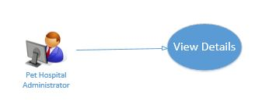

Figure 3.6 View Details Specification

*Pet Hospital Administrator* has the authority to add details upon successful login and can view the added information.

|  |  |
| --- | --- |
| **Name** | View Details |
| **Actor** | *Pet Hospital Administrator* |
| **Brief Description** | After successful login *Pet Hospital Administrator* is able to view the added details from the databases. |
| **Flow of Events** | After successful login *Pet Hospital Administrator* is able to add the details related to pets.  Added details are saved into the database. |
| **Alternate Flow of**  **Events** | If fields are missing then admin can refill them. |
| **Pre-condition** | Some information is necessary. |
| **Post condition** | Viewed information can be updated or deleted. |

##### Table 3.4: View Deals Specification

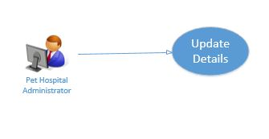

Figure 3.7 Update Details Specification

*Pet Hospital Administrator* is able to update the details and can also update the added information.

|  |  |
| --- | --- |
| **Name** | Update Details |
| **Actor** | *Pet Hospital Administrator* |
| **Brief Description** | After successful login *Pet Hospital Administrator* is able to update the added details and then again save them into database. |
| **Flow of Events** | After successful login *Pet Hospital Administrator* is able to update the details related to pets.  Updated details are saved into the database. |
| **Alternate Flow of**  **Events** | If fields are missing then admin can refill them. |
| **Pre-condition** | Some information is necessary. |
| **Post condition** | Updated information can be deleted. |

##### Table 3.5: Update Deals Specification

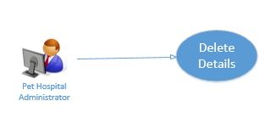

Figure 3.8 Delete Details Specification

*Pet Hospital Administrator* is able delete any details.

|  |  |
| --- | --- |
| **Name** | Delete Details |
| **Actor** | *Pet Hospital Administrator* |
| **Brief Description** | After successful login *Pet Hospital Administrator* can delete any details and then again save them into database. |
| **Flow of Events** | After successful login *Pet Hospital Administrator* can delete any details related to pets.  Updates will be saved into the database. |
| **Alternate Flow of**  **Events** | If fields are missing then admin can refill them. |
| **Pre-condition** | Some information is not necessary. |
| **Post condition** | Admin may logout. |

##### Table 3.6: Delete Details Specification

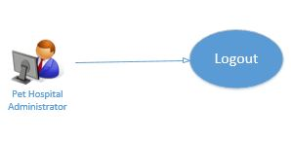

Figure 3.9 Logout Specification

*Pet Hospital Administrator* is able to logout at any time.

|  |  |
| --- | --- |
| **Name** | Logout |
| **Actor** | *Pet Hospital Administrator* |
| **Brief Description** | After successful login *Pet Hospital Administrator* is able to logout at any time. |
| **Flow of Events** | After successful login *Pet Hospital Administrator* is able to logout at any time. |
| **Alternate Flow of**  **Events** | Shut down the system. |
| **Pre-condition** | All activates are completed no more need stay log in. |
| **Post condition** | Admin is able to re login into the system at any time. |

##### Table 3.7: Logout Specification

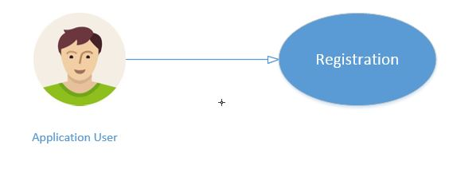

Figure 3.10 Registration Specification

First of all *Application User* will register himself by filling registration form in order to add pet profile or view others details. Provided information will be verified and after the successful registration the *Application User* *or* will be registered.

|  |  |
| --- | --- |
| **Name** | Registration |
| **Actor** | Application User |
| **Brief Description** | Application user is able to register as a new user. |
| **Flow of Events** | *Application User* will fill the registration form and then click on submit button.  Information will be validated and a verified.  After the Successful registration *Application User* will be registered  *Application User* is now able to the login. |
| **Alternate Flow of**  **Events** | If validation fails, then user can resend it.  If compulsory fields are not filled, user will be prompted to fill them all. |
| **Pre-condition** | All fields of registration age are essential. |
| **Post condition** | User will be able login. |

##### Table 3.8: Registration Specification

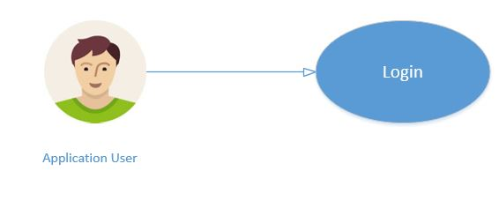

Figure 3.11 Login Specification

First of all *Application User* will register himself by filling registration form then he/she will be able to Login into the system ; in order to add/update/view pet profile or view more details.

|  |  |
| --- | --- |
| **Name** | Login |
| **Actor** | Application User |
| **Brief Description** | Application user is able to login after registering him/herself. |
| **Flow of Events** | *Application User* will fill the registration form and then click on submit button.  After the Successful registration *Application User* will be able to Login and access the application details. |
| **Alternate Flow of**  **Events** | If validation fails, then user can resend it.  If compulsory fields are not filled, user will be prompted to fill them all. |
| **Pre-condition** | All fields of login age are essential. |
| **Post condition** | User will be able to view the further details. |

##### Table 3.9: Login Specification

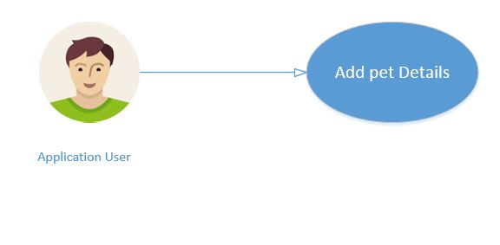

Figure 3.12 Add Details Specification

*Application User* can add pet profile details upon successful login.  *Application User* can to add more information related to pets if pet owner or user buys new pet.

|  |  |
| --- | --- |
| **Name** | Add Details |
| **Actor** | *Application User* |
| **Brief Description** | After successful login *Application User* is able to add the pet profile details and these details will be saved to databases. |
| **Flow of Events** | After successful login *Application User* is able to add the pet profiles details related to pets.  Added details are saved into the database. |
| **Alternate Flow of**  **Events** | If fields are missing then admin can refill them. |
| **Pre-condition** | Some information is necessary |
| **Post condition** | Added information can be viewed or updated or deleted. |

##### Table 3.10: Add Details Specification

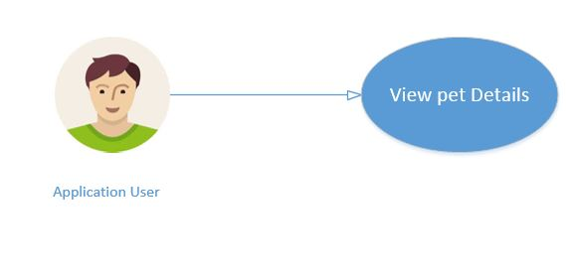

Figure 3.13 View Details Specification

*Application User* can also view the all information like pet diet plans, pet disease and treatment suggestions etc available on application or information updated by him related to pet profile.

|  |  |
| --- | --- |
| **Name** | View Details |
| **Actor** | *Application User* |
| **Brief Description** | After successful login *Application User* is able to view the details from the databases. |
| **Flow of Events** | After successful login *Application User* is able to view the details. Like pet diet plans, disease and treatment suggestion and pet profile.  Updated details of pet profiles are saved into the database. Retrieved when required. |
| **Alternate Flow of**  **Events** | If fields are missing then admin can refill them. |
| **Pre-condition** | Some information is necessary. |
| **Post condition** | Viewed information can be updated or deleted. |

##### Table 3.11: View Details Specification

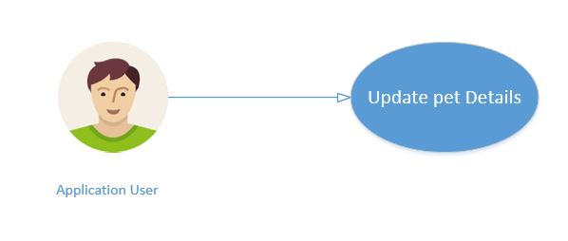

Figure 3.14 Update Details Specification

*Application User* is able to update the details but only which are related to pet profile and can also update the added information.

|  |  |
| --- | --- |
| **Name** | Update Details |
| **Actor** | *Application User* |
| **Brief Description** | After successful login *Application User* is able to update the added details but only which are related to pet profile and then again save them into database. |
| **Flow of Events** | After successful login *Application User* is able to update the details related to pet’s profiles.  Updated details are saved into the database. |
| **Alternate Flow of**  **Events** | If fields are missing then user can refill them. |
| **Pre-condition** | Some information is necessary. |
| **Post condition** | Updated information can be deleted. |

##### Table 3.12: Update Details Specification

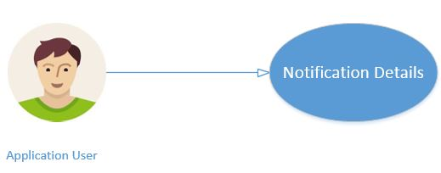

Figure 3.15 View Notification Details Specification

*Application User* can also view the all information available on application related to notifications of pet food timings.

|  |  |
| --- | --- |
| **Name** | View Notification Details |
| **Actor** | *Application User* |
| **Brief Description** | After successful login *Application User* is able to view the notification details related to pet food timings. |
| **Flow of Events** | After successful login *Application User* is able to view the notification details related to pets.  Added details are saved into the database. |
| **Alternate Flow of**  **Events** | User cannot edit the notification details. |
| **Pre-condition** | Some information is necessary. |
| **Post condition** | Viewed information cannot update or delete. |

##### Table 3.13: View Notification Details Specification

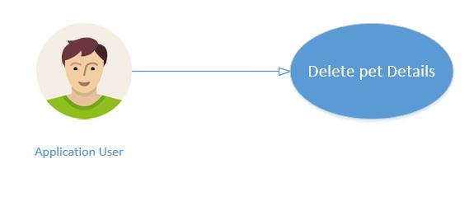

Figure 3.16 Delete Details Specification

*Application User* is able to delete details which are only related to pet profile.

|  |  |
| --- | --- |
| **Name** | Delete Details |
| **Actor** | *Application User* |
| **Brief Description** | After successful login *Application User* can delete details which are only related to pet profile and then again save them into database. |
| **Flow of Events** | After successful login *Application User* can delete details which are related to pet’s profile.  Updates will be saved into the database. |
| **Alternate Flow of**  **Events** | If fields are missing then user can refill them. |
| **Pre-condition** | Some information is not necessary. |
| **Post condition** | User may logout at any time. |

##### Table 3.14: Delete Details Specification

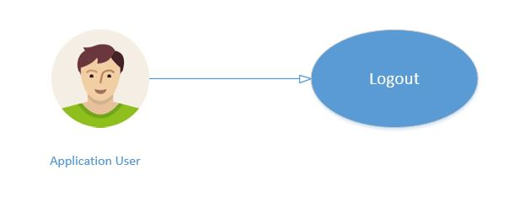

Figure 3.17 Logout Specification

*Application User* is able to logout at any time.

|  |  |
| --- | --- |
| **Name** | Logout |
| **Actor** | *Application User* |
| **Brief Description** | After successful login *Application User* is able to logout at any time. |
| **Flow of Events** | After successful login *Application User* is able to logout at any time. |
| **Alternate Flow of**  **Events** | Shut down the system. |
| **Pre-condition** | All activates are completed no more need stay log in. |
| **Post condition** | Admin is able to re login into the system at any time. |

##### Table 3.15: Logout Details Specification

**Chapter # 4**

# System Design

## 4.1 System Architecture Diagram

System Architecture Diagram is a theoretic model that defines the overall view of a system. In architecture diagram we basically have defined the whole structure of a system. Pet Hospital Administrator can register using website and can add, update, delete and view any details. On the other hand Customer/User can add, update, and delete the data which is only related to pet profile. User can view any related details which is present in database or application. The system architecture diagram is given below:

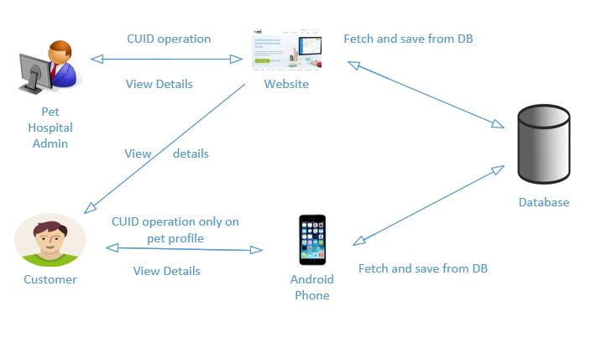

Figure 4.1 System Architecture Diagram

## 

## 4.2 Design Methodology

Agile methodology is used to develop this project as our requirements are incremental.

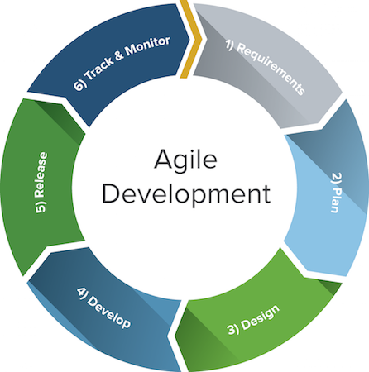

Figure 4.2 Design Model

## 

## 4.3 High Level Deign

## 4.3.1 Flow Chart

### 4.3.1.1 Flow Chart (Pet Hospital Administrator)

First of all Pet Hospital Administrator will browse the website then he will login into the system if the email and password is correct. Administrator is able to add, delete, view and update any data. Changes will be saved into the database. Admin can log out at any time.

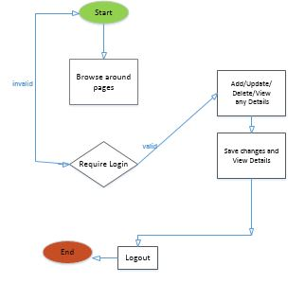

Figure 4.3 Flow Chart of a system (Pet Hospital Administrator)

### 4.3.1.2 Flow Chart (website user)

Web user first of all will login into the system. If email and password is correct then user can only view the details available on the web application. Application users can logout at any time.

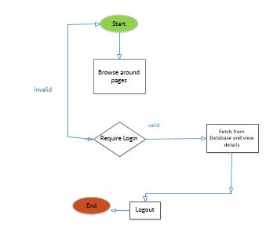

Figure 4.4 Flow Chart of a system (Website user)

### 4.3.1.3 Flow Chart (Android Application user)

First of all android user will login into the system if the email and password is correct then android will be to view details. User can add, delete and update data which is specific to pet profile. Changes in pet profile will be saved and he can fetch and re view them. Android user can make appointment or contact the doctor in case of any emergency. Android user can log out at any time.

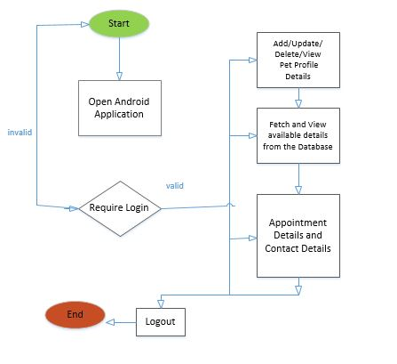

Figure 4.5 Flow Chart of a system (Android Application User)

## 4.3.2 Activity Diagrams

### 4.3.2.1 Activity Diagram (Pet Hospital Administrator)

First of all Pet Hospital Administrator will browse the website then he will login into the system if the email and password is correct. Administrator is able to add, delete, view and update any data. Changes will be saved into the database. Admin can log out at any time.

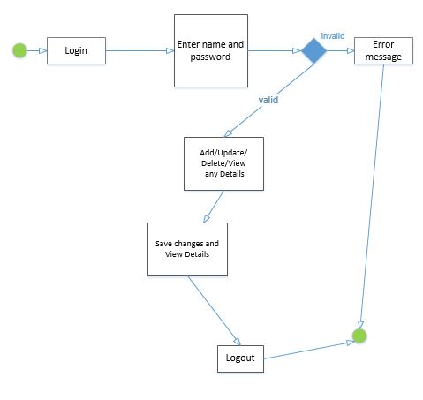

Figure 4.6 Activity Diagram (Pet Hospital Administrator)

### 4.3.2.2 Activity Diagram (website user)

Web user first of all will login into the system. If email and password is correct then user can only view the details available on the web application. Application users can logout at any time.

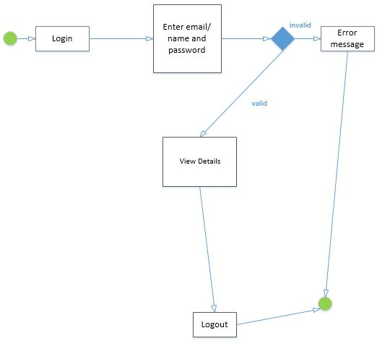

Figure 4.7 Activity Diagram for a web user

### 4.3.2.3 Activity Diagram (Android Application user)

First of all android user will login into the system if the email and password is correct then android will be to view details. User can add, delete and update data which is specific to pet profile. Changes in pet profile will be saved and he can fetch and re view them. Android user can make appointment or contact the doctor in case of any emergency. Android user can log out at any time.

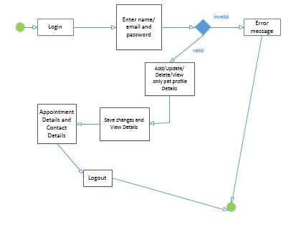

Figure 4.8 Activity Diagram for an Android app user

# References

1. Pet Coach - Ask a Vet Online for Free, 24/7. (n.d.). Retrieved September 26, 2017, from <https://www.petcoach.co/>.

2. Pet First Aid - Red Cross - Android Apps on Google Play. (n.d.). Retrieved September 26, 2017, from <https://play.google.com/store/apps/details?id=com.cube.arc.pfa&hl=en>.

3. Point, Tutorials. “Android Tutorial.” Www.tutorialspoint.com, Tutorials Point, 31 Dec. 1969, www.tutorialspoint.com/android/. Accessed 19 Sept. 2017.

4. Read and Write Data on Android | Firebase. (n.d.). Retrieved September 19, 2017, from <https://firebase.google.com/docs/database/android/read-and-write>.

5. Other Items of Interest. (n.d.). Retrieved September 19, 2017, from <https://www.raywenderlich.com/category/android>.

6. Pet Web Site. (n.d.). Retrieved September 21, 2017, from <http://www.petwebsite.co.uk/>.

7. 10 Best Apps For Every Pet Parent. (n.d.). Retrieved December 28, 2017, from <http://www.mypet.com/basic-pet-care/10-best-apps.aspx>.

8. Corpuz, J. (2017, October 24). 20 Apps for Pet Lovers. Retrieved December 28, 2017, from <https://www.tomsguide.com/us/pictures-story/1074-best-pet-apps.html#s2>.

9. Track the daily walks with your beloved four-legged friend! (n.d.). Retrieved December 28, 2017, from <https://dogwalk.tractive.com/en/>.

10. MyPet Reminders - Android Apps on Google Play. (n.d.). Retrieved December 28, 2017, from <https://play.google.com/store/apps/details?id=com.mypetreminders&hl=en>.

11. Full Android release coming soon. (n.d.). Retrieved December 28, 2017, from <http://dogsync.com/wait.php>.

12. Adopt a Pet. (n.d.). Retrieved December 28, 2017, from <https://www.aspca.org/adopt-pet>.

13. Dog Health - Android Apps on Google Play. (n.d.). Retrieved December 28, 2017, from <https://play.google.com/store/apps/details?id=it.lobofun.doghealt&hl=en>.

14. PetCoach - Ask a vet for free - Android Apps on Google Play. (n.d.). Retrieved December 28, 2017, from <https://play.google.com/store/apps/details?id=co.petcoach&hl=en>.

15. First Aid For Pets - Android Apps on Google Play. (n.d.). Retrieved December 28, 2017, from <https://play.google.com/store/apps/details?id=com.boehringer.FirstAidForPets&hl=en>.

16. Rover - Dog Boarding & Walking - Android Apps on Google Play. (n.d.). Retrieved December 28, 2017, from <https://play.google.com/store/apps/details?id=com.rover.android&hl=en>.